Wyckoff House Museum
Scavenger Hunt
Your name: __________________________________________
Draw a self-portrait!
Can you find these plants?
Write the names or draw it!
A plant with pokey or spiky  leaves or stems | A plant with leaves bigger  than your hand
A plant with leaves  that are not green | A flower with an odd  number of petals
A plant with leaves  that smell nice | The biggest flower  in the garden
Architecture by Numbers
How many of the following architectural features can you count? Don’t forget to look on the back of the house too!
Windows | Steps | Shutters | Chimneys | Doors

Architecture by Shapes
Where can you find these shapes on the exterior of the farmhouse? You can circle them on the drawing below.
Another shape?

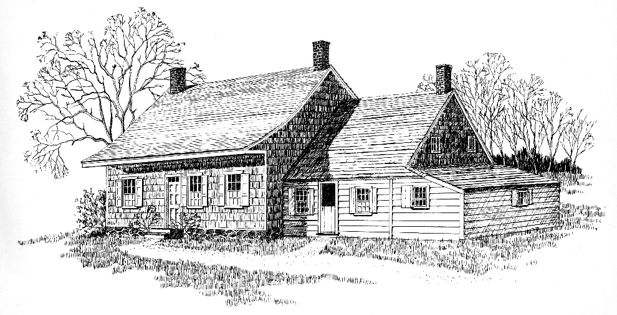
Time Travel
How has the Wyckoff house and
its neighborhood changed over time?
What are some things that you can see or hear that you might not have found here 300 years ago?

Sketch what this house might have looked like surrounded by farms, stretching as far as the eye could see.

